QUESTION 2
>>TASK A
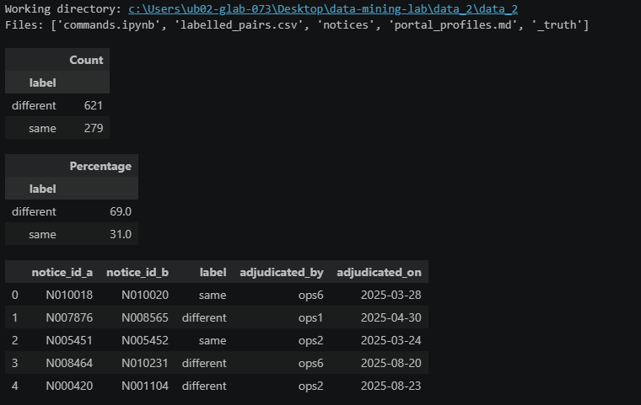
The labeled dataset contains 900 manually adjudicated pairs. Among these, 279 pairs (31%) are labeled as same, while 621 pairs (69%) are labeled as different. Therefore, the labels are imbalanced, with different pairs forming the majority.
This imbalance is important when evaluating the deduplication system because accuracy alone may not adequately represent its performance. The labeled pairs will be used as the trusted source for evaluating similarity and retrieval quality.
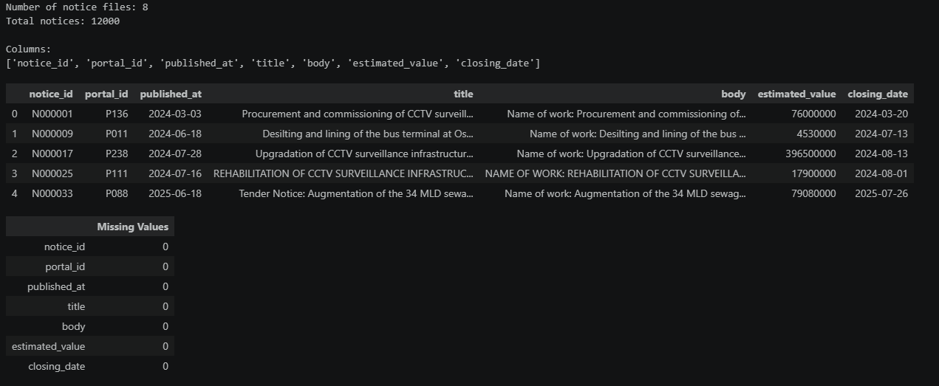
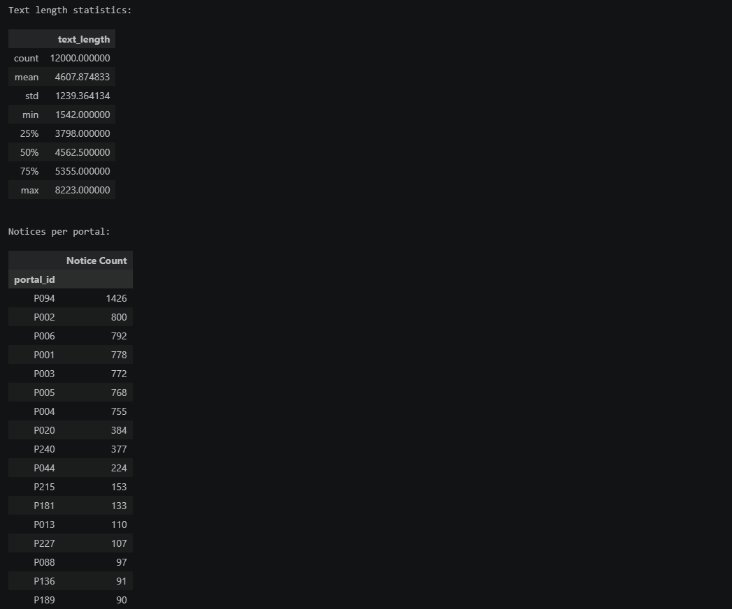
Portal formatting analysis
Key findings:
- 6 nodal portals republish notices and add around 1,400 characters of boilerplate.
- Reference numbers differ across portals.
- Corrigenda may change closing dates and add text to the original notice.
- Some portals truncate notices.
- P094 has the most notices (1,426)
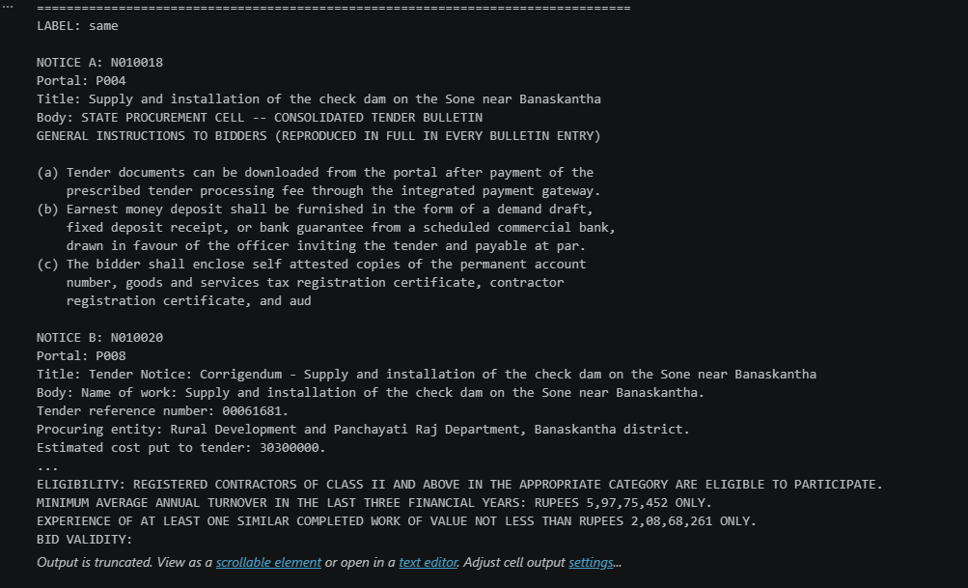
>Similarity
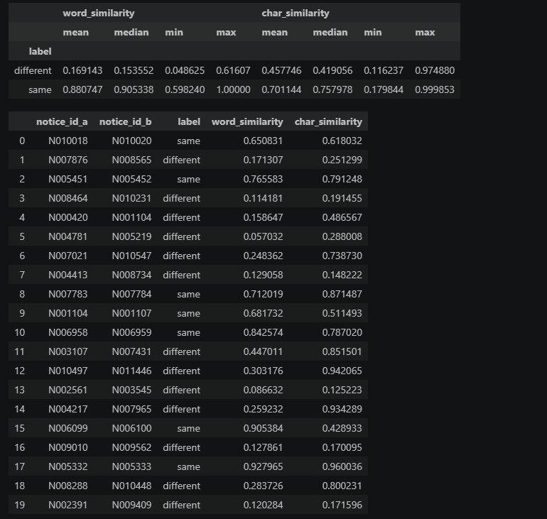

>Part b
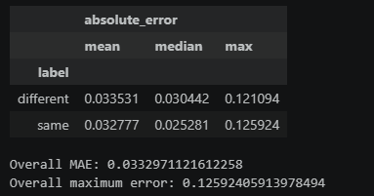
>>PART D
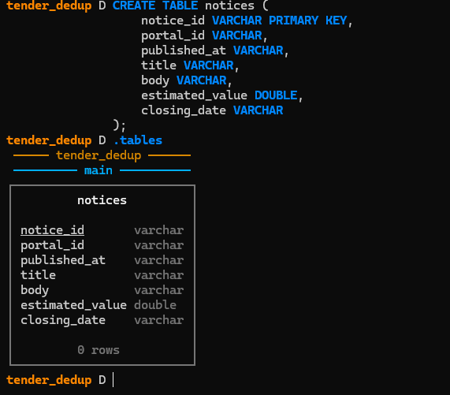
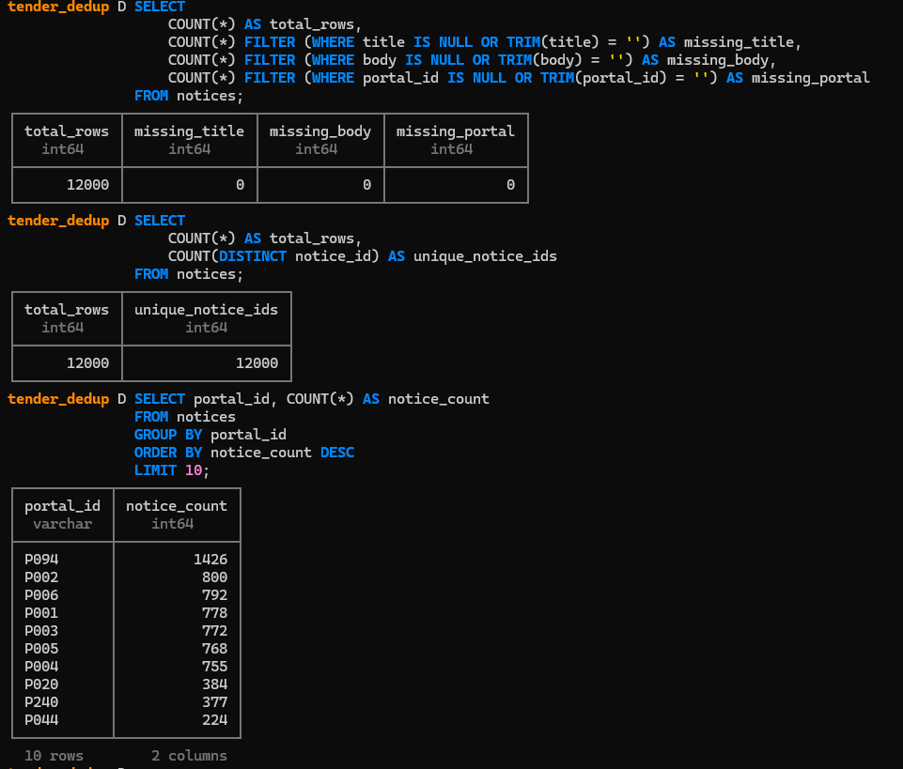
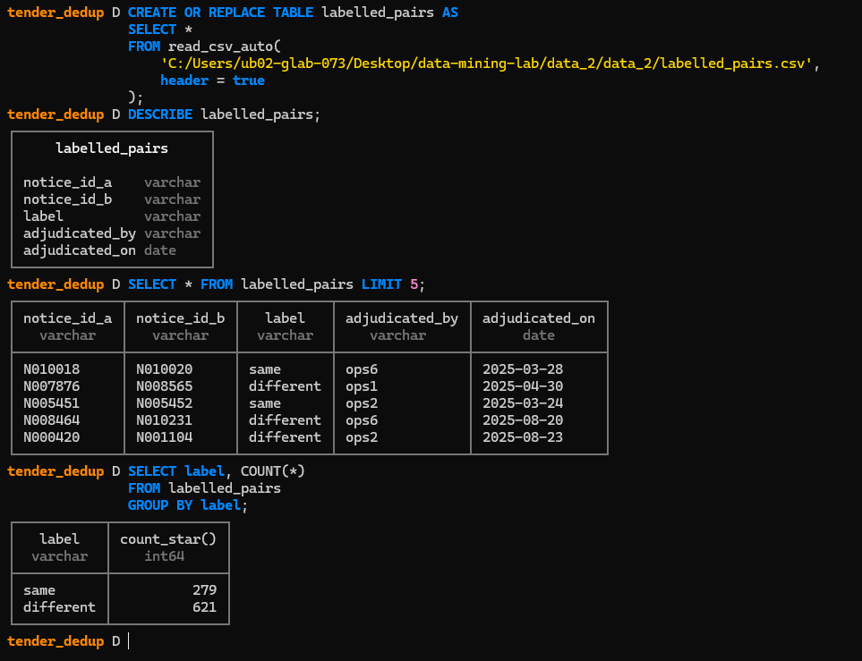
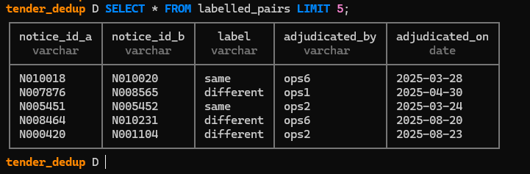
>>PART E
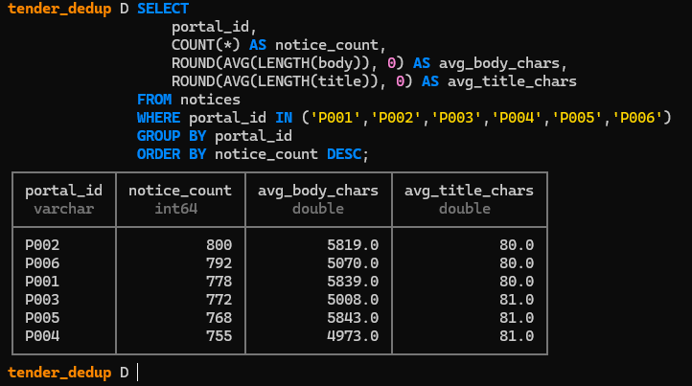
The full corpus contains 12,000 notices from multiple portals. Portal-level counts were examined to identify uneven data distribution. The six nodal portals were also compared by notice count and average text length to assess whether repeated boilerplate and notice truncation could affect retrieval workload.

